Peyyala Naganandini
723921106012
Peyyalanaganandini9550@gmail.com
Smart water fountain iot

Innovation

Introduction of Smart Water Management Systems

- One of the essential elements in the universe is water. Nowadays, consumers continuously seek methods to simplify their lives Monitoring water quality is criticalto ensuring the planet’s health and long-term viability . Water is the source of many infectious illnesses, and garbage thrown by residents and environmental disasters from industrial enterprises pollute most of the nearby freshwater supplies in SA Drinking water can be stored in an overhead tank . The principal causes of water quality deterioration in residential buildings are the development of microbes in overhead tanks and distribution networks, corrosion of pipe material, and the non-replacement of existing pipes To avoid catastrophic health implications, it is necessary to continuously and remotely check the quality parameters of the water system in real-time Traditional water quality monitoring in South Africa (SA) is expensive and does not allow continuous and timely monitoring of water quality from various sources
- Sustainable water management strives to combine many water management areas an optimize advantages in SA This can be accomplished in various ways, including water reuse, collecting, and conservation techniques

The main contributions of this paper are:
- _ Smart water management gives a greater understanding of the water system, including
- flaw detection, preservation, and water management.
- _ A comprehensive database of regions with water losses or unlawful connections can be
- built with the introduction of smart water system technology by public
- service corporations.
- _ Smart water grids can save costs by conserving water and energy while improving
- the quality of service to consumers. Wireless data transfer allows consumers to assess
- their water use to reduce water costs in other circumstances.

Relevant Survey

- Thermal characteristics have significantly impacted the environmental footprint and life-cycle evaluation of buildings. It is proposed in this study that the opacity of a façade element could be adjusted year-round in response to seasonal variations using the smart water-filled glass (SWFG) control technology described in this research. As a result of SWFG and WFG’s climate-based design strategy, glass buildings are no longer seen as climate change liabilities and instead as opportunities for sustainability . According to a new study, the Internet of Things (IoT) could monitor renters’ and landlords’ electricity and water use (IoT). One technique has made it simpler to read meters and water meters through the internet, and renters and landlords can see the data gathered through an Android application. Tenants and landlords have found the gadget and IoT-based
- Android app dependable, accurate, useful, and easy to use
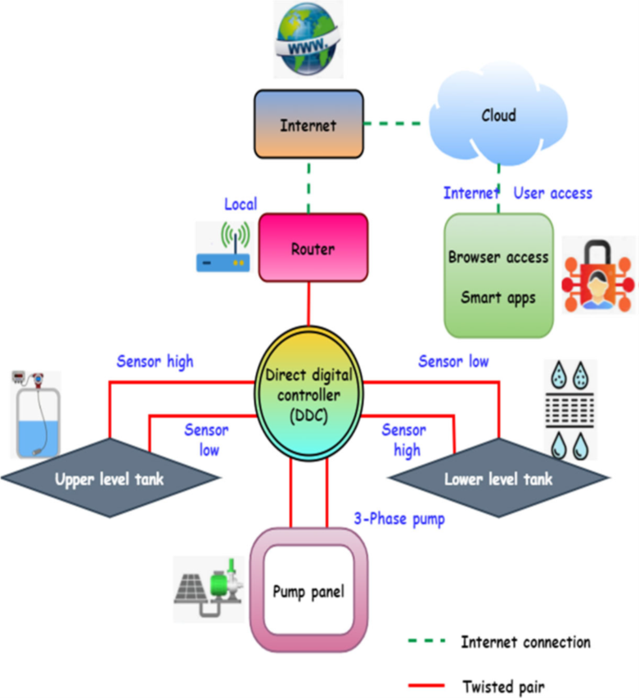
Proposed Method: IoT-Based Smart Water Management Systems

In Saudi Arabia, water supply and sanitation are marked by problems and successes.
- Water shortage is a major issue .
- Water desalination, water distribution, sewerage, and wastewater treatment have received significant investments to combat water shortages .
- Today, desalination provides roughly half of the country’s drinking water, groundwater mining provides 40%, and surface water supplies in the mountainous southwest account for 10% A desalinated water pipeline runs from the Arabian Gulf to Riyadh, Saudi Arabia’s capital and largest city.
- Consumers get water nearly at no cost. Despite these advances, the quality of service remains low, for instance, in terms of supply continuity.
- The public sector in Saudi Arabia is characterized by a widespread lack of institutional capability and governance.
- The Saudi vision 2030 addresses this challenge to be resolved .
- Among the successes is expanding wastewater treatment and processed sewage to irrigate urban green spaces and farmland
- They need a constant data connection and a lot of juice to monitor in real time. Decisions can be made in real-time with the use of cloud computing
- An increasing number of IoT devices are used in the water management system. Now that inexpensive sensors can be linked to the Internet of Things devices, we can more accurately assess water quality.

- Various urban engineering professionals gathered for brainstorming meetings to develop these concepts. An urban system can be distilled down to its most basic elements with this FBD. A typical urban system is used to conduct the internal functional analysis.
- Technical networks, housing, companies, and public infrastructure are among the many
- subsystems that urban planning experts say should be distinguished. Each of these four
- major subsystem groups includes the Saudi Arabian people.
- The FBDs have taken over most of the more specialized responsibilities. This is a good illustration of an FBD for a drinking water supply (DWS) technical network.
- It does the same thing as a bank account trust fund. A trust bank gt1 is a good option for those who cannot or do not want to maximize the use of their assets s on their own and do not have the knowledge dxl or expertise to do it themselves, stated as,
- dxl =gt1 s(x2 􀀀 x1)(1 + t1)

- According to this suggested technique, Saudi Arabia can achieve the economic level of leakage (ELL) in water loss reduction
- ELL represents the objective value of water companies, which involves looking for the highest amount of money that can be invested relative to the amount of water wasted. According to the analyzed case studies (RS and
- CMC), lowering water losses in the water distribution system is the best way to increase NRW.
- RS must have been imperative to enhance its water loss monitoring and management.
- This led to RS’s primary monitoring tools ensuring that the system was running well in
- quantity and quality.
- Other advantages include identifying district metering areas’ (DMA)
- consumption, irregular nocturnal use, and controlling water distribution network pressure.
- These devices made it possible to obtain data on water use, pressure variations, and flow or
- quality probes straight from the network.
- A central database stores all of the data acquire by these devices, decreasing the need for estimates by providing scans and regular and trustworthy recordings to the management organization.

- Disinfection must be done to the highest degree possible when dealing with blackwater
- due to the high amount of microbiological contamination.
- There are two primary considerations when matching alternate water sources with suitable end-use. It is possible
- to ensure that water obtained from a different source is adequate for its intended application
- using the least amount of treatment possible.
- The second is the amount of water coming from the alternate source. The ideal match is when the alternative source’s supply can fulfill the end consumer’s demand at the lowest possible cost. Greywater treatment can be
- used in various ways, including water for flushing toilets, watering the lawn, and cooling
- down the air conditioning unit in one’s home.
- For landscape irrigation, treated blackwater is the best option. Sewage that has been micro-filtered and disinfected, for example, can be flushed down the toilet or utilized for irrigation purposes.

- when Xwaterr = ztank Xemptyy. Ywater, pr2, Xwater, ztank, and Xempty here
- stand for the volume of water in the tank, the cross-sectional area of the tank, the radius of
- the tank, the height of the water in the tank at this time, and the total empty volume of the
- tank.
- However, modest adjustments would need to be made to the equation to account for
- various tank designs’ unique shapes and sizes. Thanks to this handy website, users may
- check their water storage tanks from any internet-enabled mobile device. Water leakage
- was not a factor in the design of this system.
- The IoT-SWM system has been proposed to
- develop the stormwater quality, efficiency ratio, water demand ratio, leakage detection ratio, and non-revenue water ratio.

- The quality of rooftop rainwater can be affected by the local environment, roof material, and regular cleaning/maintenance.
- To further understand the water’s diverse properties, we collected and examined 15 rainfall
- samples from the roofs of different buildings across the area. Samples have been analyzed
- immediately or within 24 h of being collected.
- Sterilized glass vials have been used to collect samples, subsequently transported, and kept in a freezer. The study result showed that the water samples reduced levels of chlorine anion and significant cations
- such as magnesium and calcium.
- This water meets all the requirements for safe consumption,
- including pH and electrical conductivity. As a result, the study’s findings suggestion installing a basic filtration system to catch roof sediments before they reach the storage
- tank and enhancing stormwater quality analysis by 98.7Water quality monitoring analysis. The quality of rooftop rainwater can
- be affected by the local environment, roof material, and regular cleaning/maintenance. To
- further understand the water’s diverse properties, we collected and examined 15 rainfall
- samples from the roofs of different buildings across the area. Samples have been analyzed
- immediately or within 24 h of being collected. Sterilized glass vials have been used to
- collect samples, subsequently transported, and kept in a freezer. The study results

- Water efficiency measures the amount of water required for a given operation and the volume of water used or delivered to decrease water
- waste.
- Water efficiency differs from conserving water because it focuses on minimizing waste rather than restricting usage, which seems different from water conservation
- Planning, producing, distributing, and maintaining the most effective use of water resources are all aspects of water resource management. In the ideal scenario, water resource management planning should include all competing uses and demands for water and be allocated equally to meet all needs.
- In light of these important factors, an IoT-SWM-based smart water management system design has been given. This design uses machine learning-based predictions to increase the smart management system’s efficacy further. By comparison, the suggested strategy improves efficiency by 95.1%. It is essential to have a water management program or plan to ensure that Legionella and other waterborne pathogens are not allowed
- to flourish and spread in the water systems of residential buildings.
- In addition, it has been proposed as future work to develop an Internet of Things (IoT)-based architecture
- for a smart water management system that incorporates all these crucial features and uses
- IoT-based predictions to boost its efficacy.

